**Exp No: 12 Implement Cursors**

create table login(username varchar(10) primary key, passwd varchar(10));

insert into login values("username", "password");

select * from login;

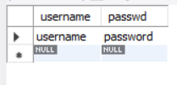

delimiter //

CREATE PROCEDURE test()

BEGIN

DECLARE i TEXT;

DECLARE n TEXT;

DECLARE curs1 CURSOR FOR SELECT username,passwd FROM login;

OPEN curs1;

FETCH curs1 INTO i,n;

SELECT i,n;

CLOSE curs1;

END//

call test()//

